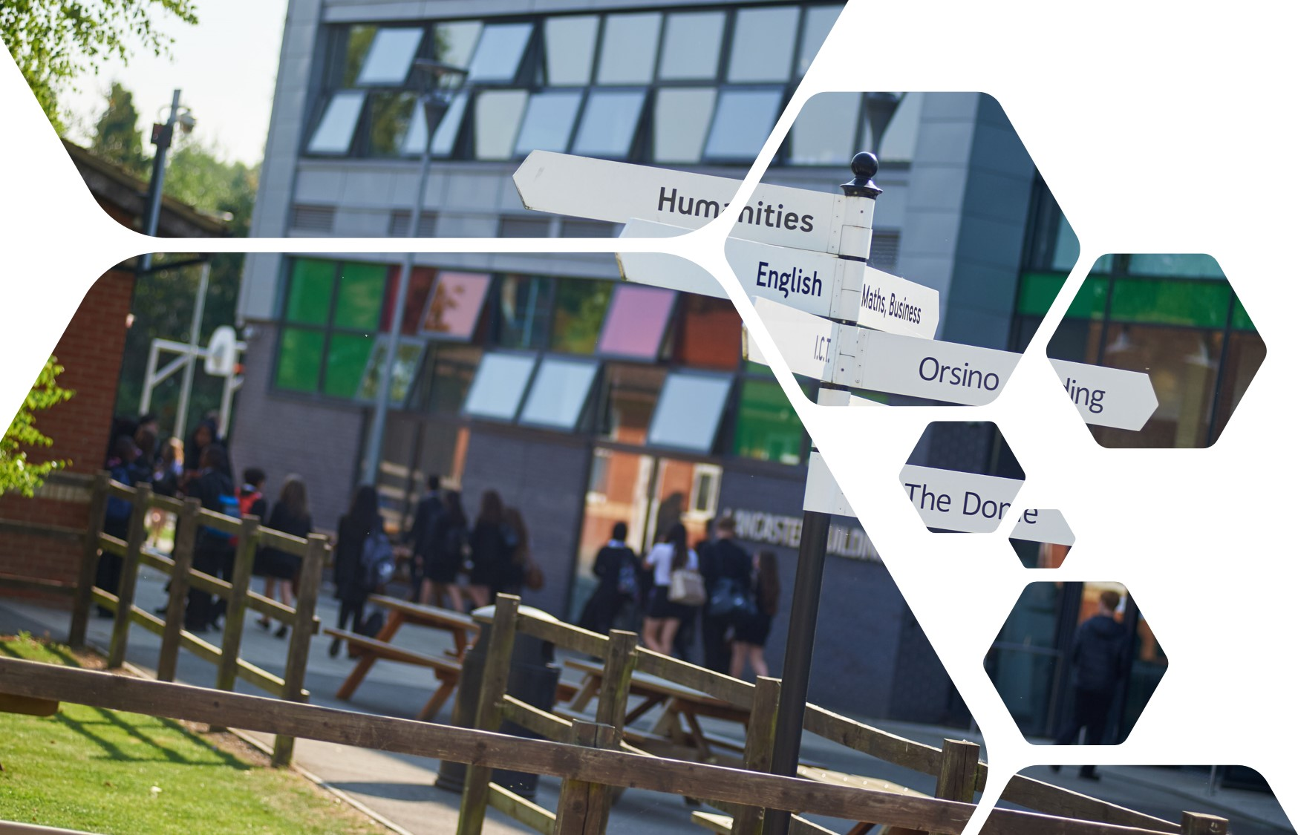

Sixth Form Transition Pack
LEVEL 3- FINANCE (LIBF)

Finance What to expect?
To the untrained eye, Finances can appear to behave in slightly peculiar ways. Why have Cadburys decided to pay more for Fair Trade cocoa beans? Why have Apple released two versions of the same phone? Why has Hotel Chocolat opened a second ‘bricks and mortar’ outlet in Manchester when ecommerce is becoming more popular?

The answers to these questions will provide an insight to the strategies of some of the most successful organisations in the world. Level 3 Finance Studies is not only a qualification; it’s a handbook for anyone thinking of entering the complex world of commerce.

In our Finance courses, you will apply knowledge and understanding to real-life Finance contexts, with updated content to reflect the issues impacting on modern Finances in our specification and real Finance case studies in all our assessments.

You will develop transferable skills that support higher education study and the transition to employment, including numeracy, communication, an understanding of the Finance environment and commercial awareness.
The common question that gets asked in Finance is, 'why?' That's a good question, but an equally valid question is, 'why not?'
Jeff Bezos, founder of Amazon

The finance course is 100% exam based and consists of 4 units. Two which is done in Year 12 (Certificate level) and two which is done in Year 13 (Diploma level), the diploma is equivalent to one whole A Level.
Each unit exam is out of 100. Out of the 100, 35 marks are Multiple choice question based and the remainder 65 marks are written based.

The course is provided by the London Institute of Banking & Finance.
The course is a great way for an individual to be prepared for the real world after education. We learn about mortgages, finance, banking and taxation, interests rates etc.

Expectations of you
The Finance Level 3 course is the next step after successfully completing GCSEs. Level 3 is designed to build on your previous learning and knowledge and assist you in developing the necessary skills to complete the course. For you to excel at Level 3 and achieve your targets, you need to acknowledge and agree to the following;

  - Attendance = attainment. Attend all lessons, arrive on time and bring all the necessary equipment and resources. Do not book appointments during lesson hours.
- Work to the best of your ability in class and focus on the lesson
  - Listen respectfully to the views of other students and consider how your own views are developing
  - Complete all homework on time – this includes printing out resources
  - Keep up-to-date with Finance in the news either online or via newspapers
  - Complete all necessary research (as directed)
  - Make sure you check your emails and are part of the relevant email groups for additional resources and tasks.
  - Attempt all work. If you are unsure of what to do, of course you may ask questions, but you must develop greater independence
  - Take advantage of any spare time to work develop your ideas or seek help on areas you’re unsure of
  - Keep to deadlines!

Resources
One you have been enrolled in the subject; you will receive the official LIBF textbooks free of charge. This textbook contains key course theory, that must be covered by yourself if you wish to do well in the subject.

Use the LIBF website to see the specification.
https://www.libf.ac.uk/study/financial-capability

And you can look online at additional resources, especially here: www.tutor2u.net/Finance

Task to be completed
If you’ve just finished your GCSE in Business Studies, you’ll be familiar with the exam technique and structure. Level 3 Finance is similar, but now you have to develop your answers and opinions more – adding counter-arguments and referencing theorists like Maslow and Herzberg as and when needed.

The following tasks are designed to develop your exam technique, highlight your current
strengths in writing and developing an answer and provide you with an example of the types
of questions you may be asked in a Level 3 Finance exam.

Government to recruit 20,000 new police officers

A national campaign to recruit 20,000 new police officers has been launched which urges people to join the police and 'Be a force for all'. The police recruitment drive is the biggest in decades and follows the Prime Minister's commitment to increase police numbers over the next 3 years.

To do: You are to do a research task and find out why the police have decided to recruit 20,000 officers over the course of a 3 year period. As part of your research, you need to look into the current/past policing structure here within the UK and look at how this recruitment drive is going to support with current economic and social issues that we face here in the UK.
- Reading
Recruitment of 20,000 new police officers to begin 'within weeks'
https://www.bbc.co.uk/news/uk-49123319

Have police numbers dropped?
https://www.bbc.co.uk/news/uk-47225797

Will there really be 20,000 police officers?
https://www.theguardian.com/politics/2019/nov/11/election-fact-check-will-there-really-be-20000-new-police-officers

Police cuts contributed to rise in murders in Britain, Home Office report says
https://www.independent.co.uk/news/uk/crime/police-cuts-rise-murders-britain-home-office-latest-figures-a9377551.html
- Watch

Boris Johnson launches police recruitment drive in Wakefield
https://www.youtube.com/watch?v=G0x1k6p8PJU

Government launches police officer recruitment drive
https://www.youtube.com/watch?v=yhMSfAm22uE

Be a force for all – Fareesha’s story
https://www.youtube.com/watch?v=TRD24yxRuBw

General election: Campaign check looks at the 20,000 extra police officers promise
https://www.youtube.com/watch?v=TijSAzFvpjU

Up close with county lines
https://www.youtube.com/watch?v=JPXlx9C0Rxs

Revealing the unreported story of county lines drug dealing - our new podcast Air Time | ITV News
https://www.youtube.com/watch?v=wi1iXdyxl70

Parents lift the lid on the damage county lines does to families | ITV News
https://www.youtube.com/watch?v=tZPx0ZIY8sA

- Research
- How much money will it cost the government to fund the recruitment of police officers
- How much money is made from county lines gangs throughout the UK
- How many teenagers are involved in county lines in the UK
- How might the coronavirus have an impact on the recruitment drive of police officers
- What are the key skills and attributes needed to be a successful police officers
- Write

- Analyse one reason why police are recruiting 20,000 officers over the next 3 years
- Analyse one reason how economic conditions contributed to police jobs being cut/lost in recent years.
- Explain what County Lines is
- Explain one problem police officers have with dealing with County Lines

Essay questions – both worth 25m each
- To what extent will the recruitment of police officers stop the county lines drug gangs?
Structure: 5 paragraphs
2 x MEEL reasons saying why it will stop the county lines drugs
2 x MEEL reasons saying why it will not stop the county lines drugs
1 x conclusion
- With the recruitment of 20,000 police officers in the UK over the next 3 years, recommend the best way that they should be utilised to support and look after the British Society. To take into account, issues such as; Neighbourhood safety, stop and search, online safety, domestic violence, counter terrorism, county lines etc..
Structure: 5 Paragraphs
1x MEEL picking one way the police officers should be used to protect society
1x MEEL picking one way the police officers should be used to protect society
1x MEEL picking one way the police officers should be used to protect society
1x MEEL picking one way the police officers should be used to protect society
Conclusion – answer the question directly

Please make sure to highlight the connective you use before sending me your work.

Work to be submitted to Mr Ahmed in the first lesson back.

You should email it by 11.59pm on Wednesday, 2nd September 2020

Good luck,

