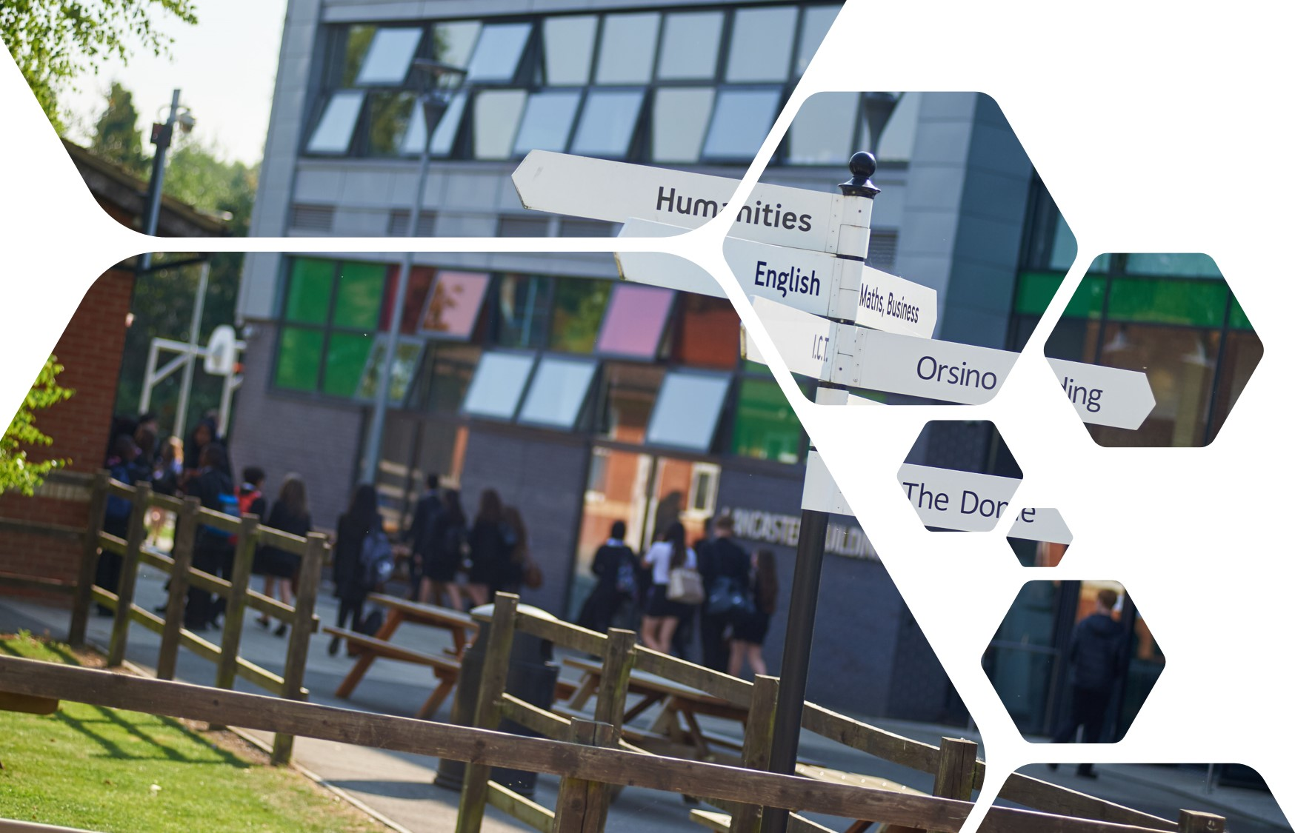



|  |
| --- |
| Sixth Form Transition  Pack –  BTEC SPORT  LEVEL 3 |

|  |  |  |
| --- | --- | --- |
|  |  |  |
|  |  |  |

# course INTRODUCTION

|  |
| --- |
|  |

## Essential summer reading

## **BTEC National Sport, Student Book 1 (Pearson, 2016)**

## **BTEC Sport Level 3, Revision Guides (Pearson, 2017)**

## **Exercise Physiology and Functional Anatomy (Feltham Press, 1995)**

## **Mechanics and Sport Performance (Feltham Press, 1998)**

## **Sports rule books and coaching guides**

## **Sports Biographies / Autobiographies**

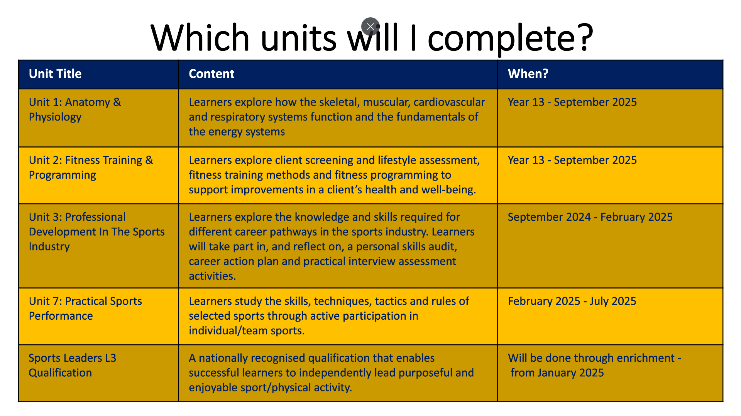

## Task to be completed

## Skeletal system <https://www.youtube.com/watch?v=rDGqkMHPDqE>

## Muscular system <https://www.youtube.com/watch?v=Ktv-CaOt6UQ>

## Respiratory System <https://www.youtube.com/watch?v=bHZsvBdUC2I>

## Cardiovascular System <https://www.youtube.com/watch?v=_lgd03h3te8>

## Energy System <https://www.youtube.com/watch?v=00jbG_cfGuQ>

**Additional tasks to complete**

|  |
| --- |
| Research the rules, regulations, skills, techniques and tactics in one individual sport and one team sport.  Include the following for each:   * 7 x rules/Laws * 5 x regulations (competition rules e.g. Euro 2020 rules) * 3 x skills, techniques and tactics   Use a range of video scenarios to help you judge the application of rules and how they impact each sport.  You can include the following information:   * Rules/laws as regulated by the national or international governing body for the two selected sports * Competition rules/laws and regulations * Unwritten rules and/or etiquette specific to sport * Regulations for sports under competition rules |

